**Unit-I**

**DC Power Transmission Technology**

Now a day, the quality of electric supply is becoming more importance due to the use of sophisticated computer control systems. The power system network in India is a big network and it is divided different regions in order to get the following advantages.

1) Effective monitoring on the network. So, that the outage of the network will be less.

2) If the outage of network will be less, the interruptions are less. So that the reliability of supply is high

3) Due to reliability of supply the revenue of the system will increase.

At any point of time, the frequency regarded in any two stations will be same. So that the power can be allowed in directly an ac manner because the frequency is same which is known as ”**synchronous transmission**”.

At any point of time, the frequency regarded in any two stations will be of two different regions is not same and if they join directly to allow power flow in an ac manner then the two regions will get ”**Asynchronous transmission**”.

However in modern power system network, it is necessary to allow the power flow from one region to another region, which can be possible by having asynchronous transmission between two regions, is called as “**HVDC Transmission**”

The DC transmission requires a converter at each end of the line. The sending end converter acts as a rectifier converting ac to dc and receiving end converter acts as an inverter converting dc to ac.

**Apparatus required for HVDC system:**

The schematic diagram of HVDC system is shown in figure

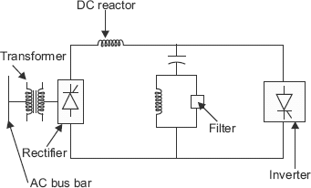

The apparatus required for HVDC system are

**1) Converters**:

Converters are used to convert the power from ac to dc or dc to ac. Minimum two converters are required for transmission, one at sending end and other at receiving end. The converters at the sending end acts as rectifier, which converts power from ac to dc and the receiving end converter acts as an inverter converting dc to ac.

**2) Smoothing reactors**:

Smoothing reactors are used to reduce the ripples obtained on Dc lines and to reduce the harmonic voltages and current in the DC lines. By using these reactors we can limit the magnitude of the fault current i.e., we can minimize the rate of raise of fault currents.

**3) Filters**:

The filters are used to reduce the harmonics that are generated by the converters on both sides i.e., on ac as well as dc side. These are used in both sides of transmission line providing low impedance path for harmonic currents.

**4) Shunt capacitors**:

Shunt capacitors are used to increase the load capability in conductors. These capacitors are used to provide the reactive power for the converters which are because of phase displacement of current and voltage in an ac system. The reactive power consumption is in the range of 50-60% of its active power.

**5) DC lines:**

The DC lines are overhead lines or cables. The design of these lines is similar to that of an ac lines design. The selection of conductor is made are designed by considering corona losses and field effect. The no of insulators can be determined by using DC voltage.

**6) Circuit Breakers**:

Circuit breakers are the switchgear components which is the current under condition to protect the circuit from damage. However, circuit breakers are used for clearing AC faults only. For clearing Dc faults, converter control circuits are used.

**7) Electrodes**:

The conductors that are used to minimize the current densities and voltage gradients are known as electrodes. The electrodes must possess low resistance path. In order to place an electrode into the earth, the resistivity of the earth should be around 3-10Ω per meter.

**Comparison of AC & DC transmission:**

|  |  |
| --- | --- |
| **HVDC transmission system** | **Ac system** |
| 1**)**It is economical for transmission of power above breakeven point i.e., for long distances | 1)It is economical for transmission of power below breakeven point i.e., for small distances |
| 2)Number of conductors required for transmitting power is less | 2)Number of conductors required for transmitting power is more |
| 3)Doesn’t require any intermediate substations for reactive power compensation | 3)Require intermediate substations for compensation |
| 4)Very fast and accurate power flow control is possible | 4) power flow control is slow and very difficult |
| 5)Skin effect is absent resulting in uniform distribution of current density across the cross section of conductor | 5) Skin effect is present due to which current density is non uniformly distributed across the cross section of conductor |
| 6)Corona loss and radio interferences are absent resulting in less insulation level required for the transmission line | 6)Corona loss and radio interferences are more due to which high insulation level required for the transmission line |
| 7)Voltage in the line doesn’t fluctuate with load | 7)Voltage in the line fluctuate with load |
| 8)Doesn’t require double circuit, earth return is used | 8) Always requires a double circuit |
| 9)Transmission through underground or marine is also possible | 9)Limit is imposed on the length of the cable |
| 10)Transmission losses are less due to absence of flow of reactive power | 10)Transmission losses are more due to the flow of reactive power |
| 11)DC breakers used in this systems are of high cost | 11)The circuit breakers used in this systems are of low cost when compared to DC circuit breakers |

**Types of DC links:**

**1)Monopolar HVDC link**:

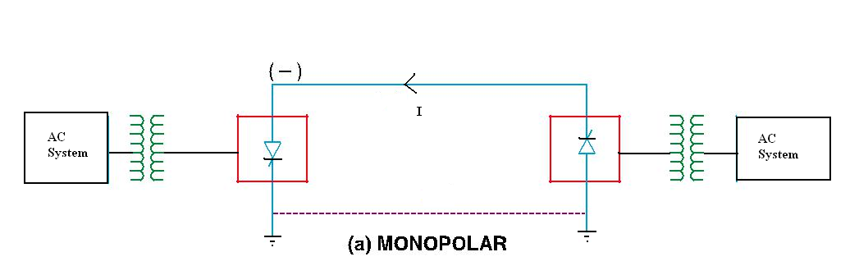

In a monopolar HVDC link; there is only one conductor the other conductor will be referred as ground. The isolating transformer is used in HVDC links. There is an electrical isolation between primary and secondary windings.

In order to reduce corona loss, the monopolar HVDC link will be preferred to work with negative polarity.

At positive polarity conductor, the mobility of the electron will be high. So the critical disruptive voltage is less which will result as the corona loss is high.

The power handling capacity is less and also the reliability of the supply is less.

The terminal equipments are supply through isolating transformer having a unity transformation ratio.

The purpose of isolating transformer is to provide effective fault clearing between the AC supply and also DC supply.

**ADVANTAGES:**

* The corona effect in a DC line is less because of the negative polarity of the line conductor as compared to the positive polarity in AC.
* Less conductor material is required as ground is used as the return path.
* Negative polarity is preferred because of less radio interference.
* Less insulation cost.

**DISADVANTAGES:**

* Ground return path is objectionable as it leads to corrosion of buried metallic structures such as pipes, cables, fences, etc.
* Causes disturbances in underground communication systems.
* Power transmitting capacity is less as compared to Bipolar and Homopolar systems.
* Power interruption problems due to faults are frequent.

**2) Bipolar HVDC link:**

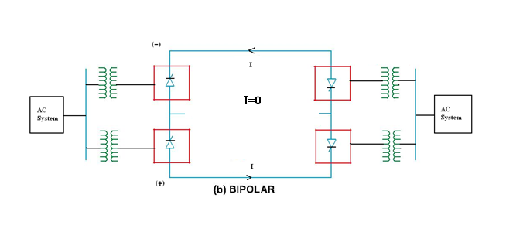

In order to overcome the disadvantages of monopolar HVDC links, the bipolar HVDC links are employed.

The Bipolar HVDC links having two conductors. One is having positive polarity w.r.t ground and the other is having negative polarity w.r.t ground. Due to this, each link will carry 50% of total power.

There are two converters of equal voltage rating and connected in series at each end of DC line.

The rating of bipolar line is expressed as ±650kv.

**ADVANTAGES:**

* Power transmitting capacity is doubled when compared to monopolar link.
* If a fault occurs in one conductor, power can be transmitted through ground therefore, power interruptions can be avoided.
* Reliability is high when compared to monopolar link.

**DISADVANTAGES:**

* Terminal equipment cost is high.
* More conductor material is required.
* Radio interference is high.
* Corona loss is high.

**3) Homopolar HVDC link:**

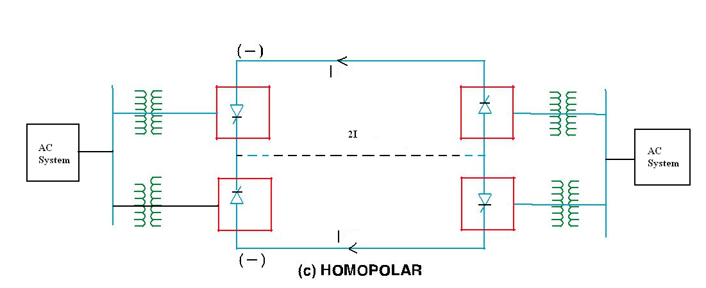

It is consisting of two or more HVDC links and all are them working with negative polarity (in order to reduce corona loss).

**ADVANTAGES:**

* Corona effect is less in negative polarity conductors.
* Less conductor material is required because ground is used as the return path.
* Negative polarity conductor has less radio interference.
* We can avoid power interruption due to faults by transmitting power through other conductors.
* Reliability is high.
* Insulation costs are low.

**DISADVANTAGES:**

* Ground return path causes corrosion of buried metallic structures.
* Causes disturbance in underground communication cables.

**Converter station:**

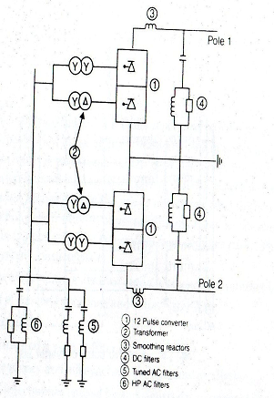

A typical converter station with one 12 pulse converter unit per pole is shown in above figure. The various components of a converter station are discussed below.

**1) Converter unit**:

This usually consists of two three phase converter bridges connected in series to form a 12 pulse converter unit as shown in figure.

The total number of valves in such a unit are twelve.The valves can be packaged as a single valve,double valve or quadric valve arrangements. Each valve is used to switch in a segment of an AC voltage waveform. The converter is fed by converter transformers connected in star/star and star/delta arrangements.

The valves are protected using snubber circuits, protective firing and gapless surge arrestors.

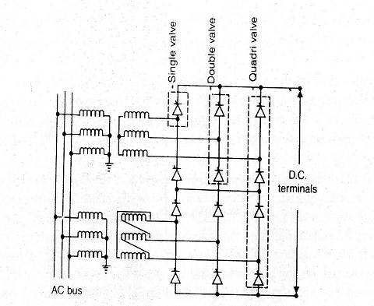

**2)Converter Transformer**:

The converter transformer can have different configurations

1)3-Ø,two winding

2)1-Ø,three winding

3)1-Ø,two winding

The valve side windings are connected in star and delta with neutral point ungrounded.On the AC side, the transformers are connected in parallel with neutral grounded.

The converter transformers are designed to withstand DC voltage stresses and increased eddy current losses due to harmonic currents.

**3)Smoothing Reactors**:

Smoothing reactors are used to reduce the ripples obtained on DC lines and to reduce the harmonic voltages and current in the DC lines. By using these reactors we can limit the magnitude of the fault current i.e, we can minimize the rate of raise of fault currents.

**4) Filters**:

AC filters are passive circuits used to provide low impedance, shunt paths for AC harmonic currents. Both tuned and damped filter arrangements are used.

DC filters are similar to AC filters for design. These are used for the filtering of DC harmonics.

**Modern trends in HVDC transmission:**

In the future, power systems would include a transmission mix of AC and DC. Future controllers would be more and more microprocessor based which can be modified or upgraded without requiring hardware changes and without bringing the entire system down.

In the future, it is expected that fiber optic system will be used to generate firing signal and the direct light fired thyristor will be used to HVDC converters. Availability of 100mm thyristors has eliminated, the need of paralleling thyristors as these can handle currents of the order of 4kA.

Although , presently HVDC schemes can operate perfectly well without the assistance of DC circuit breakers. We have to extend the point to point to other DC circuit breakers.

Already discussed HVDC is reliable, efficient and cost effective alternative to HVAC for many applications. Currently a great deal of effort is being devoted to further research and development in solid state technology due to which the HVDC converters and multi terminal DC systems will play a great role in 21st century.

12 pulse converter results in reduced filtering requirements. By the application of zinc oxide gapless arrestors and protective firing methods, the cost of valves is reduced.

**Applications of DC transmission system:**

1.High power transmission by overhead lines for long distances.

2.Medium and long high-power submarine or underground cables.

3.Multi-terminal HVDC system for interconnecting three or more than three-phase systems.

4.Frequency conversion.

5.Electric traction.

6. Interconnection between power systems or pools

7. High power underground distribution system feeder:

8. Multiple connections of networks.

9. Stabilizing Ac system by modulating DC power flow.

**Comparison of AC and DC transmission:**

The relative merits of the two modes of transmission (AC and DC) which need to be considered by the system planner are based on the following factors:

**1. Economics of transmission**:

The cost of a transmission line includes the investment and operational costs. The investment cost includes transmission towers, conductors, insulators and terminal equipment. The operational cost includes mainly the cost of losses.

Two conductors are used to transfer the power in case of DC line.

Three conductors are used to transfer the power in case of AC line.

Dielectric losses in power cables is also very less for DC transmission.

The corona effects on DC conductors tend to be less significant than for AC and this also leads to the choice of economic size of conductors with DC transmission.Fig.1.1shows the variation of costs of transmission with distance for AC and DC transmission. For distances less than breakeven distance, AC tends to be economical than DC and costlier for long distances.

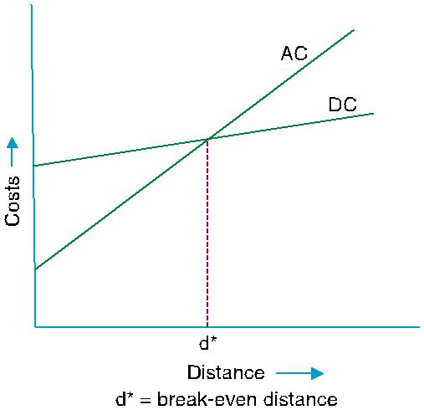

**Fig. 1.1:** Variation of costs with line length

**2. Technical performance**:

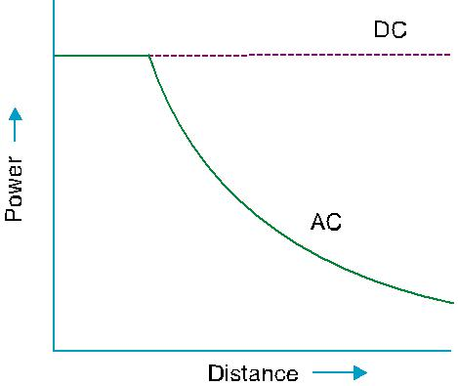The DC transmission has some positive features i.e, mainly due to fast controllability of power in DC lines through converter control.

**1) Stability limits:**



The power transfer in AC lines is dependent on the angle difference between the voltage phasors at the two ends. For a given power level, this angle increases with increase in distance. In AC power transfer is limited. But the power transfer capability is not affected in case of DC transmission. Fig shows the power carrying capability of AC and DC.

**2)Voltage control:**

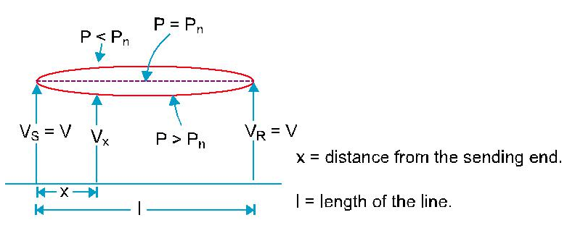

**Fig. 1.3:** Variation of voltage along the line

The voltage control in AC lines in complicated by the line charging and inductive voltage profile in AC line is relatively flat only for a fixed level of power transfer corresponding to surge impedance loading(SIL). For constant voltage at the line terminals, the midpoint voltage is reduced for line loading higher than SIL and increased for loadings less than SIL.

This is shown in fig. To maintain constant voltages the surge impedance loading is equal to voltage profile (pn=p)

If the voltage profile is less than the surge impedance loading then the voltages will increase (p<pn).If voltage profile is greater than the surge impedance loading then the voltage will decrease (p>pn).

**3) Line compensation:**

AC lines require shunt and series compensation in long distance transmission, mainly to overcome the problems of line charging and stability limitations. Series capacitors and shunt inductors are used for this purpose. The increase in power transfer and voltage control is also possible through the use of shunt connected static var compensator (SVC).

**4) Ground Impedance:**

In AC transmission, the existence of ground currents cannot be permitted in steady state due to high magnitudes of ground impedance which will not only affect efficient power transfer, but also result in telephone interference. The ground impedance is negligible for DC currents and a DC link can operate using one conductor with ground return(monopolar operation).

**3. Reliability:**

The reliability of DC transmission systems is quite good and comparable to that of AC systems. The performance of thyristor valves is much more reliable than mercury arc valves. For the development of direct light triggered thyristor (LTT) can improve reliability because of elimination of high voltage pulse transformers and auxiliary supplies for turning on the devices.

These are two measures of overall system reliability

1) Energy availability=100[1-(equivalent outage time/total time)]%

2) Transient reliability=(100*no. of times HVDC performed)/(no. of

Recordable AC faults)